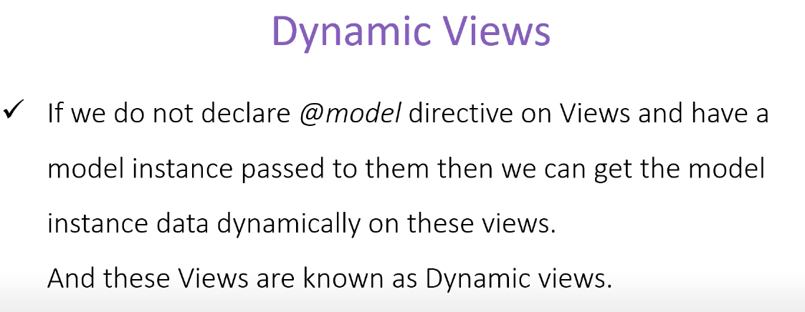

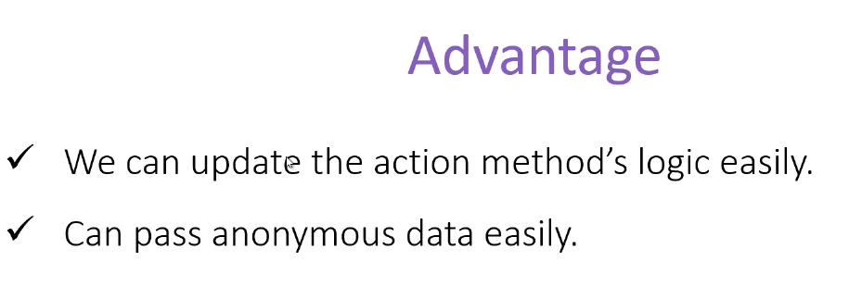

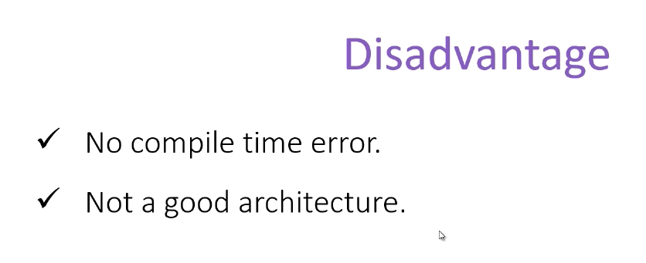

I would rather not use it, just put here for learning purpose, error prone since any type wont be caught at compile time but rather on run time. Best to avoid this